***LOGICAL DATABASE:***

**DESCRIPTION-**

The **aim** of this case study is to design and develop a database for the hospital to maintain the records of various departments, rooms, and doctors in the hospital. It also maintains records of the regular patients, patients admitted in the hospital, the check up of patients done by the doctors and patients discharged from the hospital.

* **Department-**

CREATE TABLE department

(dept_id varchar(70),

dept_name varchar(70),

PRIMARY KEY(dept_id , dept_name)

);

INSERT INTO `department` (`dept_id`, `dept_name`) VALUES ('d01', 'orthopedic'), ('d02', 'pathology');

INSERT INTO `department` (`dept_id`, `dept_name`) VALUES ('d03', 'Emergency'), ('d04 ', 'Gynaecology');

INSERT INTO `department` (`dept_id`, `dept_name`) VALUES ('d05', 'oncology'), ('d06', 'cardiology');

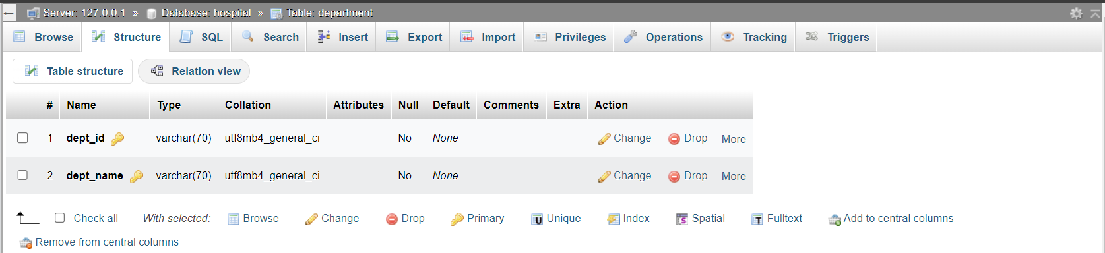

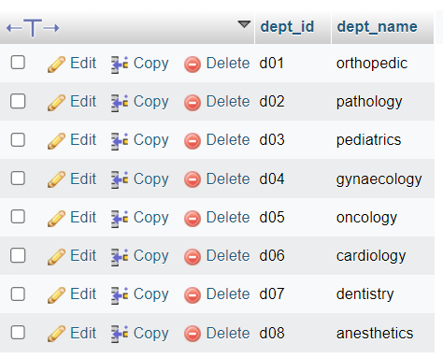

* **Rooms-**

CREATE TABLE rooms

(room_id varchar(50),

room_type char(50),

room_cost int(50),

PRIMARY KEY (room_id)

);

INSERT INTO `rooms` (`room_id`, `room_type`, , `room_cost`) VALUES ('r_05', 'private', '7000'), ('r_06', 'private', '7000');

INSERT INTO `rooms` (`room_id`, `room_type`, , `room_cost`) VALUES ('r_01', 'deluxe', '1500'), ('r_02','deluxe', '1500');

UPDATE `rooms` SET `room_cost` = '1500' WHERE `rooms`.`room_type` = 'deluxe';

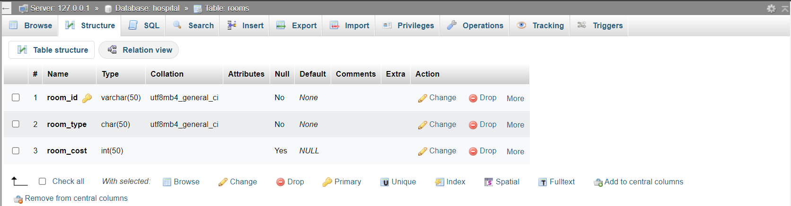

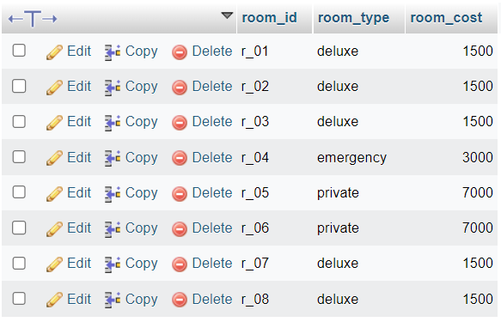

* **Doctor-**

CREATE TABLE doctor

(id varchar(50),

doc_type varchar(50),

short_name varchar(50),

PRIMARY KEY (doc_type),

);

INSERT INTO `doctor` (`emp_id`, `doc_type`, `short_name`) VALUES ('e_03', 'permanent03', 'komali');

INSERT INTO `doctor` (`emp_id`, `doc_type`, `short_name`) VALUES ('e_04', 'permanent04', 'kullad'), ('e_05', 'visiting05', 'tom');

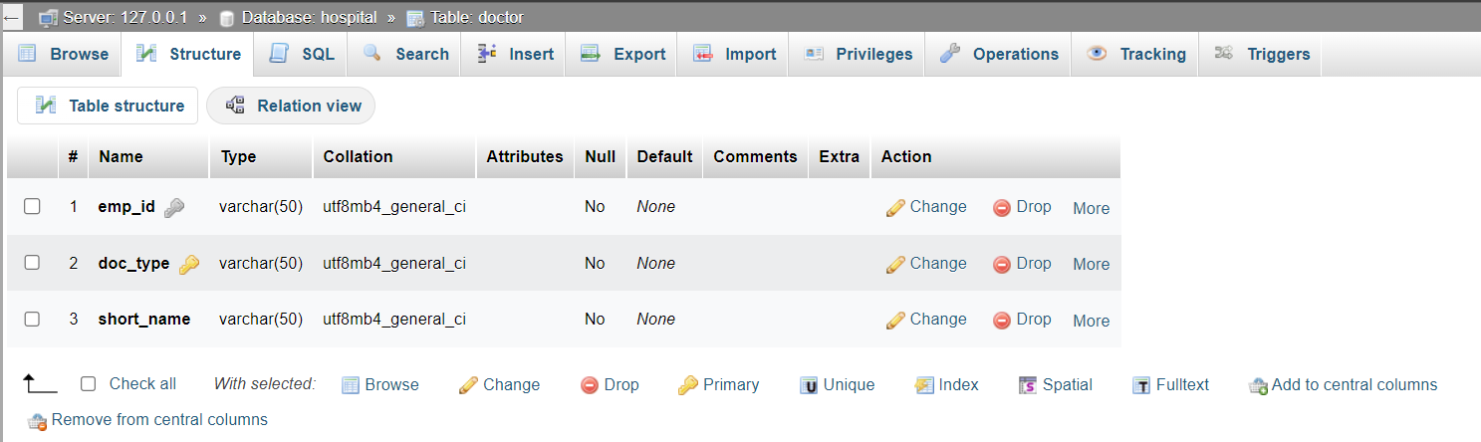

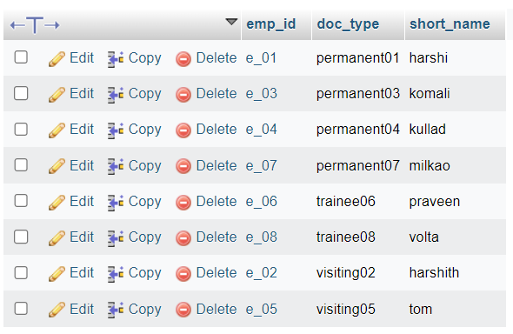

* **Patient-**

CREATE TABLE patients

(p_id varchar(50),

pa_name varchar(50),

contact_info bigint(100),

PRIMARY KEY (p_id,p_name)

);

INSERT INTO `patients` (`p_id`, `pa_name`, `contact_info`) VALUES ('pat_01', 'mike ross', '9012345678'), ('pat_02', 'harvey specter', '8761234000');

INSERT INTO `patients` (`p_id`, `pa_name`, `contact_info`) VALUES ('pat_03', 'donna schmitz', '876000111'), ('pat_04', 'ronaldihno', '789012343');

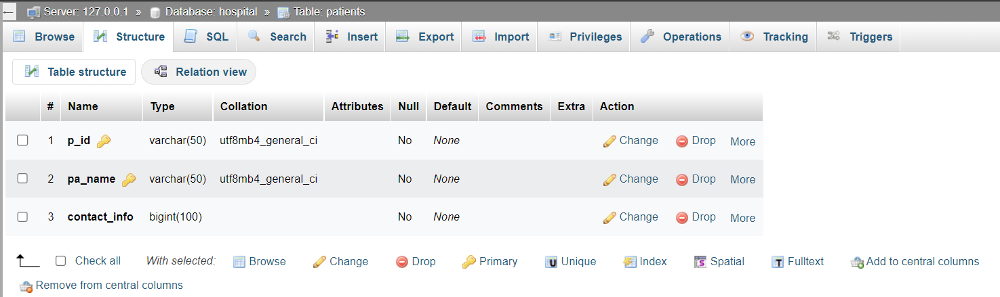

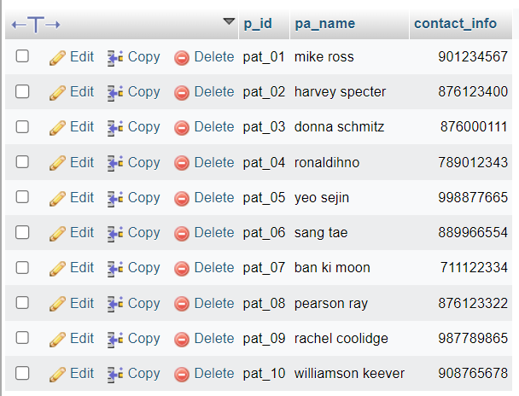

**Outform-**

CREATE TABLE outform

(form_no varchar(20),

p_id varchar(50),

doc_type varchar(50),

dept_id varchar(50),

room_id varchar(50),

checkout date,

PRIMARY KEY (form_no),

FOREIGN KEY (p_id) references patients(p_id),

FOREIGN KEY (doc_type) references doctor(doc_type),

FOREIGN KEY (dept_id) references department(dept_id),

FOREIGN KEY (room_id) references rooms(room_id)

);

INSERT INTO `outform` (`p_id`, `form_no`, `room_id`, `emp_id`, `doc_type`, `checkout`) VALUES ('pat_01', 'form_01', 'r_02', 'e_02', 'visiting02', '2022-06-03'), ('pat_02', 'form_02', 'r_01', 'e_05', 'visiting05', '2022-08-15')

INSERT INTO `outform` (`p_id`, `form_no`, `room_id`, `emp_id`, `doc_type`, `checkout`, `dept_id`) VALUES ('pat_03', 'form_03', NULL, 'e_04', 'permanent04', NULL, 'd04 ');

INSERT INTO `outform` (`p_id`, `form_no`, `room_id`, `emp_id`, `doc_type`, `checkout`, `dept_id`) VALUES ('pat_04', 'form_04', 'r_03', 'e_03', 'permanent03', '2022-08-23', 'd03');

INSERT INTO `outform` (`p_id`, `form_no`, `room_id`, `emp_id`, `doc_type`, `checkout`, `dept_id`) VALUES ('pat_05', 'form_05', 'r_06', 'e_06', 'trainee06', '2022-08-31', 'd06');

INSERT INTO `outform` (`p_id`, `form_no`, `room_id`, `emp_id`, `doc_type`, `checkout`, `dept_id`) VALUES ('pat_07', 'form_09', 'NULL', 'e_03', 'permanent03', 'NULL', 'd03');

INSERT INTO `outform` (`p_id`, `form_no`, `room_id`, `emp_id`, `doc_type`, `checkout`, `dept_id`) VALUES ('pat_08', 'form_09', 'r_04', 'e_06', 'trainee06', '2022-10-01', 'd06')

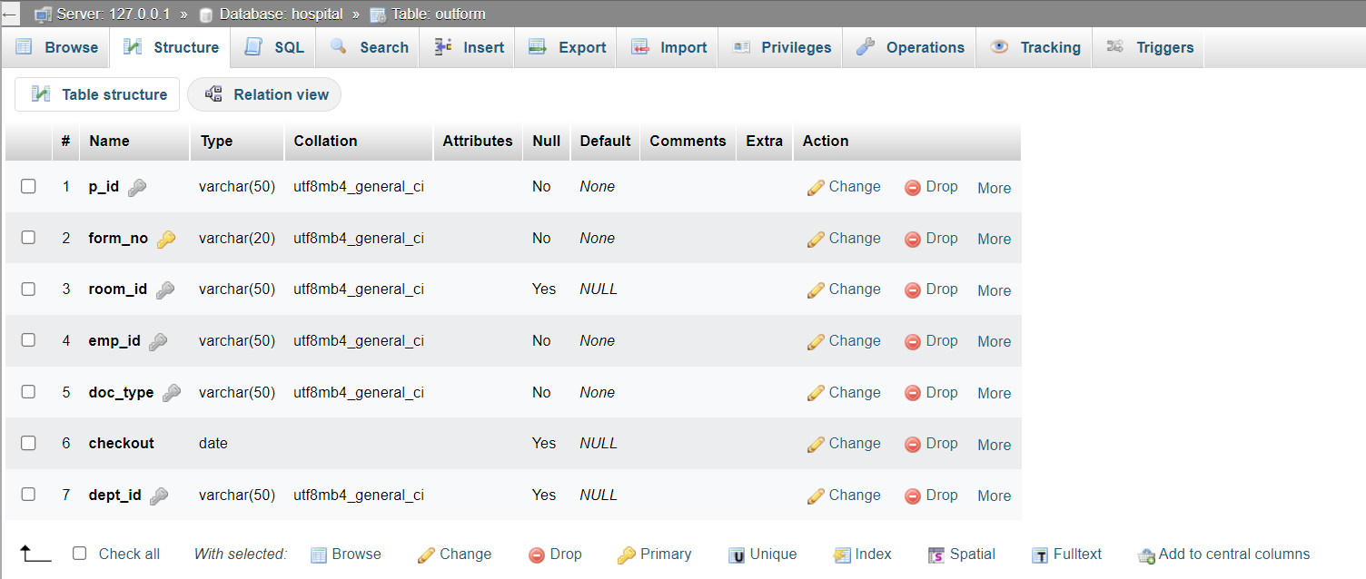

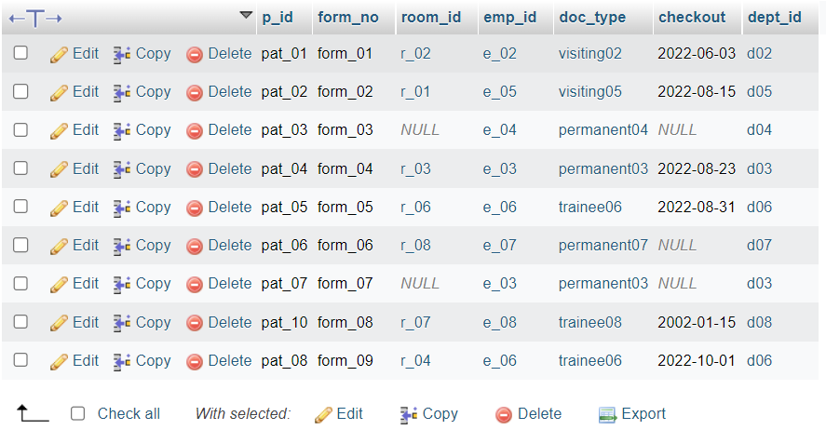

* **appointments-**

TABLE appointments

(userid varchar(50),

apptid varchar(50),

Consultancy fee int(50),

docid varchar(50),

specialization varchar(50),

PRIMARY KEY (apptid)

);

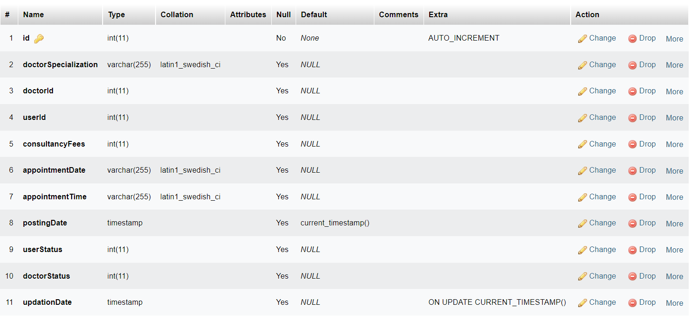

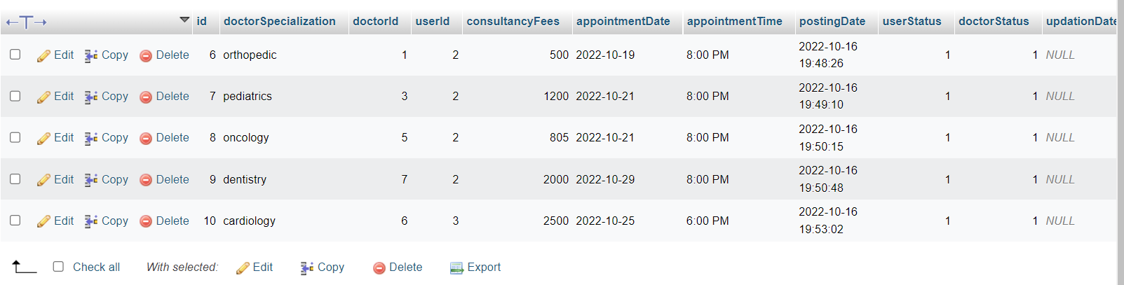

* **admin-**

TABLE admin

(username varchar(50),

password varchar(50),

);

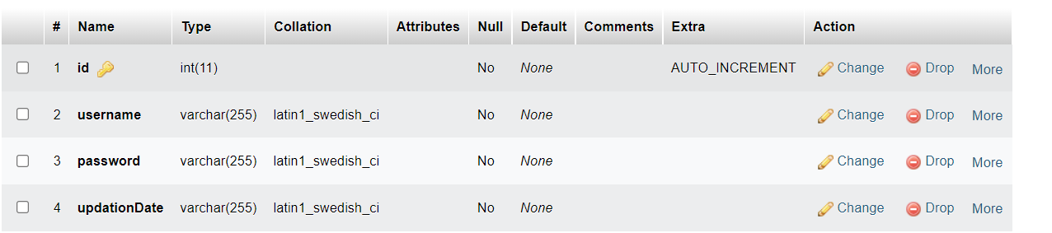

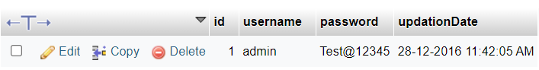

* **user-**

TABLE user

(id varchar(50),

fullname varchar(50),

Address varchar(50),

city varchar(50),

gender varchar(50),

);

